

Problem 1: Connect-4

This is a two-player game. To win, get four of your counters in a straight line, either up and down or on a diagonal

Visit <http://www.freeworldgroup.com/games/connect4/index.html> and play the game with computer to know how it works.

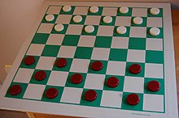

Problem 2: Draughts or Checker

<https://en.wikipedia.org/wiki/Draughts>

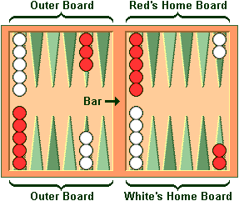

Problem 3: Backgammon

https://www.bkgm.com/rules.html